Industrial, Manufacturing, & Systems Engineering
College of Engineering

Systems Engineering Project Practicum
Summary
Project Title: | Body Drying and Inspection Apparatus
Team members: | 1. Jesus Bensojo  2. Eric Lucero  3. Hugo Mendieta  4. Paul Quinones  5. Maria Villaverde
Instructor: | Dr. Oscar Mondragon
Semester, year: | Spring 2018
Type of project: | Individual project at students work ( )  Team project assigned by instructor (X )  Project proposed by team ( )

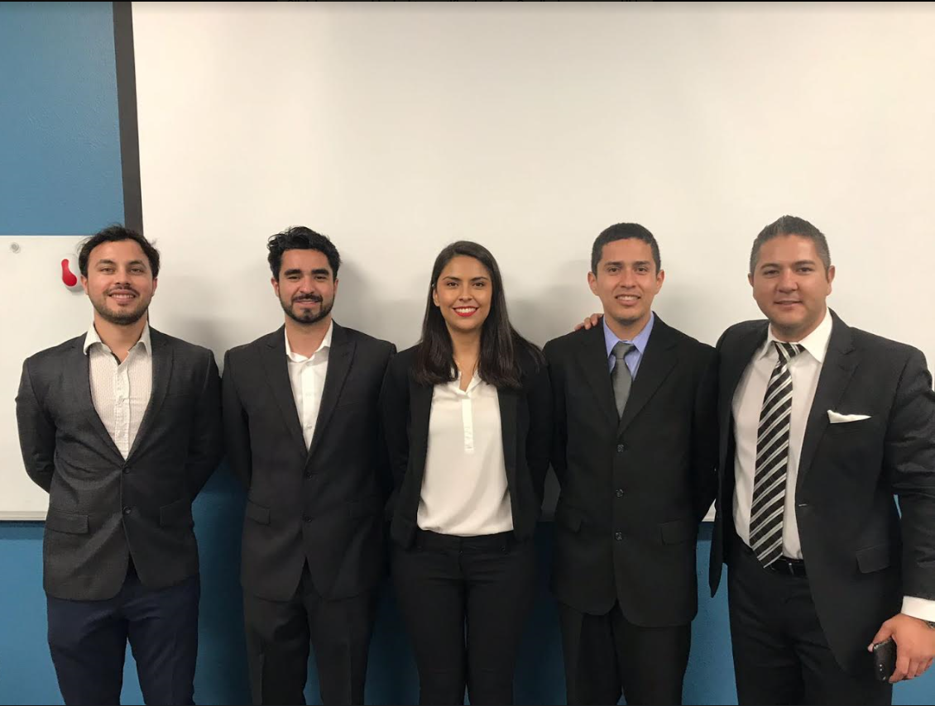

Hugo Mendieta, Eric Lucero, Maria Villaverde, Paul Quinones, & Jesus Bensojo

INTRODUCTION
The System Engineering Project Practicum provides the opportunity to apply System Engineering concepts in developing a real system and create documents that formally describe the system. Students review documents and validate them with clients and customers through formal presentations. Teams are self-managed and assign roles to control planning, quality, requirements, design, and implementation.

System Overview
The purpose of this project is to create the necessary specification and requirements for medical device to assist people with Diabetes. A Body Drying and Inspection Apparatus (BDIA) are provided for air-drying and for providing the user with several inspection and data input devices. The apparatus comprises a base platform and an upright member with one or more handles to support the user. A blower assembly forces air through the base platform and through an elongated blower tube handled by the user. Further provided is an inspection camera coupled to the blower tube and a foot camera within the base platform, both used to capture images of the user’s body while on the platform. A display and processing system is also provided that allows images to be processed and displayed, for input to be received via a user input device, and optionally for data to be transmitted to a third party over a network (healthcare provider). The base platform also provides weight-measuring capabilities for measuring the weight. The reason for this device is there are many people around the globe that suffer from the disease “Diabetes”. Because of this many people have their toes/fingers or limbs amputated if the disease gets out of hand and are not watched carefully, it can lead to death if not treated correctly. The devices helps in this area by allowing clinicians to observe the foot area, and others, were diabetes can cause life threatening issues, as well as take regularly biomedical readings.

System Description
The system works by the patient (user) stepping on to the platform of the device and completing several monitoring services for their daily biomedical readings. This include but are not limited to, blood pressure, glucose, pulse/pulse oximetry, weight. Once these readings are taken the device goes on to process its main function of drying and taking images of the feet and diabetic affected areas. Once completed, the device will transmit all necessary information and data to clinician for review. This will be completed once daily as an ongoing effort to monitor diabetes.
Below are several of our diagrams for the project.
Context Diagram
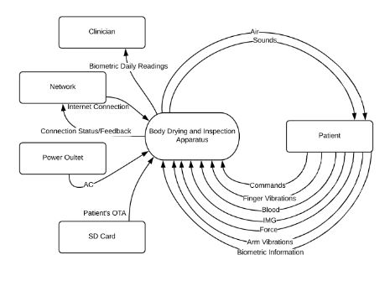
Main Use Case with Actors/Services
Actors:
Patient: The diabetic user who will be operating the device. This is also consists of the patient's family or friends as they will have the ability to interact with the device at the patients request.
Clinician: The patients healthcare clinician who will interpret and evaluate the devices data to determine the status of the patient. These consist of the Primary Physician, Endocrinologist, Podiatrist, Surgeons, Physician Assistants, Nurse Practitioners, etc.
Services:
Monitoring: The device will dry the patient's feet and body parts in order to help reduce the outcome of diabetic foot ulcers. As well as help take necessary diabetic readings and photos for the patients clinicians to help further evaluate and monitor their status.

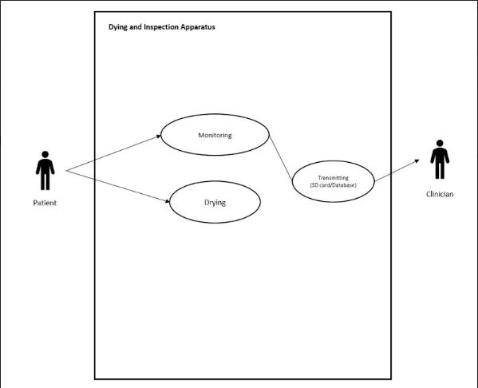
Activity Diagram, Drying Service
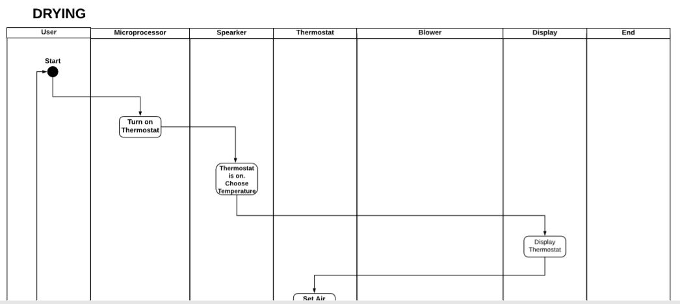
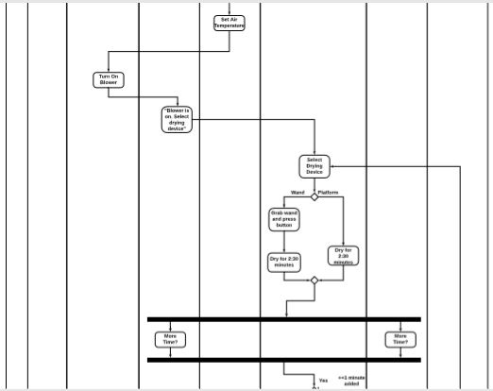
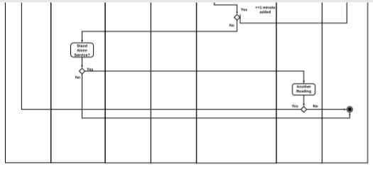
Activity Diagram (Image Service)
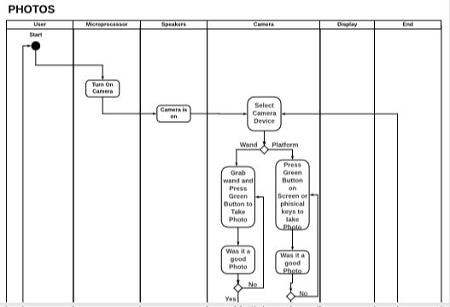
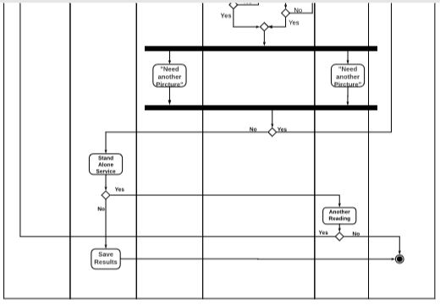
Block Definition Diagram (BDD)
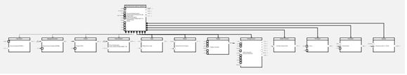
Internal Block Diagram (IBD)
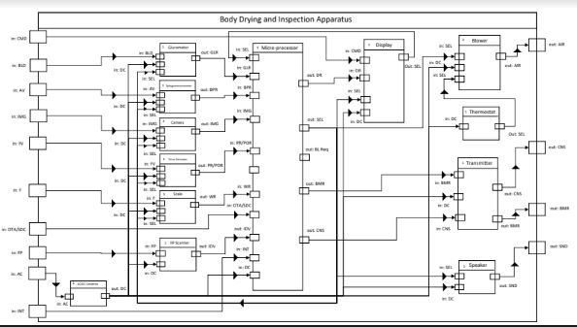
Sequence Diagrams (Drying Service)
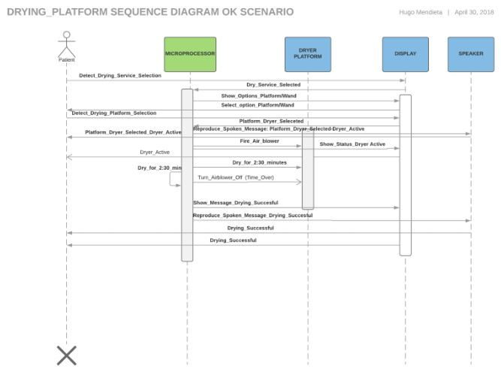
Sequence Diagrams (Image Service)
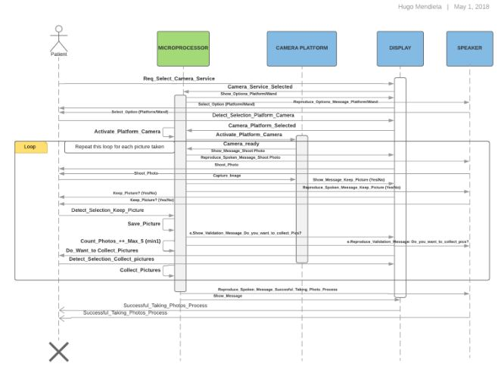

PROJECT OUTCOMES
This system will provide the organization with enough experience when dealing with real customers.
Our impressions on the how the reviews impact the quality of the system where that everytime we did a review it helped us realise we had errors on our documents. This helped us improve the quality of our system. While it also made us inject some errors to the documents.
Below is a picture of the quality dashboard and how the system performed during this timeline.
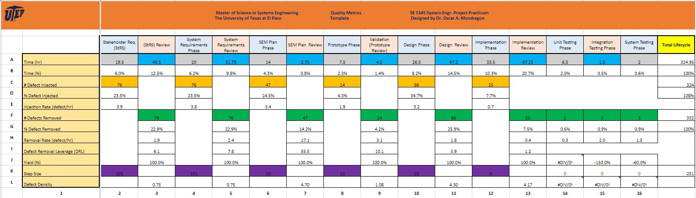
In order to perform complete this project we had to develop certain skills with the need to get along well and always bring our basic materials like computers, and have better communication as a team.
In order to be successful we had to equally split task between group members and get together on saturdays to do a follow up on the assignments that were assigned.

MASTERS OF SCIENCE IN SYSTEM ENGINEERING PROGRAM ASSESSMENT
During our time in the systems engineering program we have learned and gathered the necessary knowledge in what goes into the the planning and writing of the necessary documents that go into developing new products, as well as learn the knowledge to communicate and manage customers on a daily basis in order to meet cost and schedules for the future projects and systems we will be in charge of later in our career.
During the master’s program we acquired/developed the following skills:
- Strong work ethic
- Communication skills
- Creative problem solving
- Time management
- Teamwork
- Leadership
- Patience

